Sustainability Challenge
Mock Draft
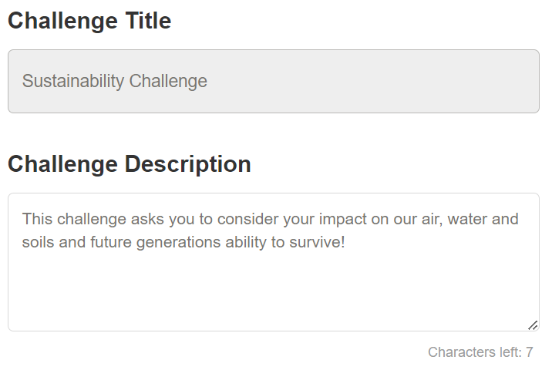
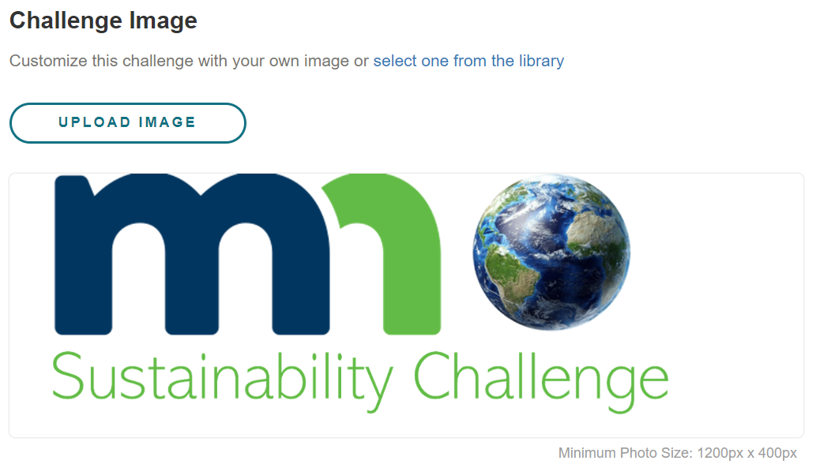

To support life on earth, we need to have clean air, water, and healthy soils. Your daily choices make a big difference in the health of these systems! By paying attention to what you buy, how much energy and water you use, minimizing and eliminating waste from your life and minimizing your overall emissions, you can make a huge difference in the long-term health of our planet and home. Commit to challenging yourself to try new ways of living! You can save money, improve your mental and physical health, and support our planet and future generations ability to survive!
You will receive 50 points (and a healthier planet) for completing at least 20 out of 28 days of the challenge. To earn points:
- In the top navigation section of Virgin Pulse hover over “Home” and then select “Rewards”
- In the “Participation” section select “Participate in a well-being event at work or in your community”
- Enter first and last name, enter “Sustainability Challenge” for the well-being event name
- Click the box and then select “SUBMIT”

FOOD
- Reduce wasted food by keeping a wasted food log.
- Eliminate red meat from your diet.
- Eliminate all meat from your diet (vegetarian).
- Eliminate all animal products from your diet (vegan).
- Join a CSA and/or start a garden.

WATER
- Take shorter showers. Keep all showers under 5 minutes and try not to exceed 20 total minutes per week.
- Complete a water calculator.
- Look for leaks.
- Reduce flushes. Only flush after "number two" to reduce your toilet water use.
- Reduce appliance water usage. Only run your dishwasher when it's full; don't run water while handwashing dishes. Only run your washing machine when it's full and your laundry is truly dirty.
- Identify changes you can make to your purchasing and consumption for a smaller water footprint.
- Use rain barrels, rain gardens, and plant native plants.
CONSUMPTION & WASTE
- Conduct a “single use” audit of your home. Swap out any single-use items for reusable.
- Keep a waste log. Log everything you throw away for the month of April and identify ways to eliminate waste or avoid it with a reusable or refillable alternative.
- Commit to reuse. Borrow, rent, repair and buy used.
- Commit to a “buy nothing” month.
- Install a yard waste and/or compost bin.
ENERGY & TRANSPORTATION
- Wash your laundry in cold water and hang to dry.
- Commit to reducing energy use.
- Opt for renewable energy with your utility.
- Walk, bike, carpool and reduce vehicle transportation miles by half.
